ver.20180725
The date of application：
Your name：
Company/Shop name：
Address：
Contact telephone number：
Phone number can be contacted on the event day：
E-mail address： ＠
Preferred date： 〜
Purpose of use：

(tax-included)
□ Exhibitions | ¥10,000 × days ＝ yen
□ Gatherings | people ＝ yen
□ Café or Restaurant  ※In the case of the event with eating and drinking, 3,000 yen a day is added  as the water, lighting and heating expenses.  1,500 yen half a day | The water, lighting  and heating expenses yen
□ Lodging | people× days＝ yen
□ Cleaning of sheets | ¥1,000 × people ＝ yen
 | Total yen

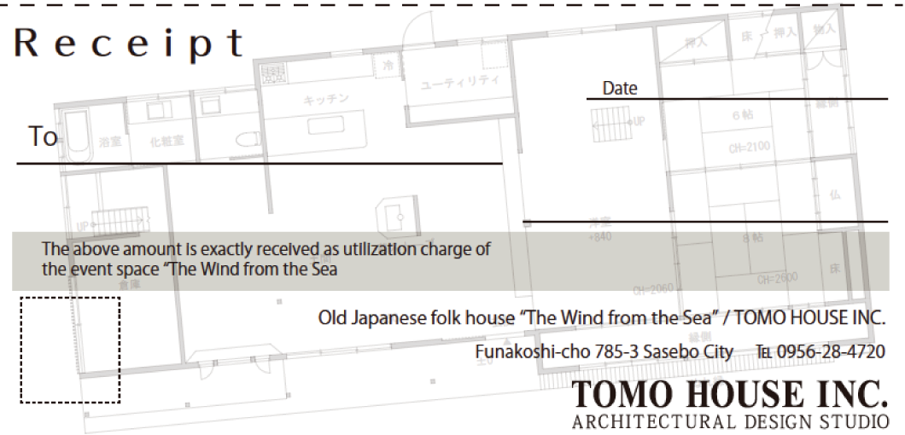
yen

